Step by Step Procedure for setting up Industrial Part numbers
The easiest way to set up a part number is to find a like item that already exists, go to the “View Item” tab and click the “Copy”button.
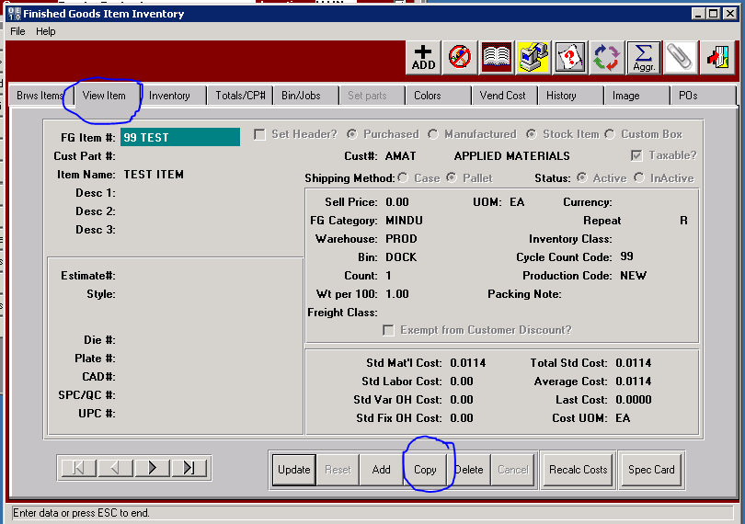
The “FG Item #:” Will be highlighted in blue, at that point you need to create the NEW part number.
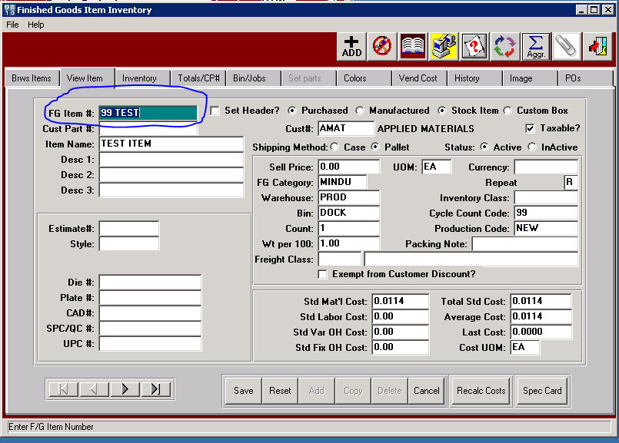

Each circled field seen on the screen below will have to be entered properly:
- Customer Part number if one exists.
- Item Name: Try to use something different than what is already showing in the part number. Example (04 EARPLUGF13) - yellow ear plugs so you would want start the description with the word “Yellow” ……. That way you can look up the item two different ways, by “YELLOW” or by “04 EAR”.
- Desc 1: Give best description possible
- Desc 2: Extended description and UOM such as “M”, “CS”, “RL” (display as M or EA=CS or EA=RL), very important for proper shipping and billing.
- Desc 3: Line does not print on paperwork; this line can be used for additional notes.
- Click Purchased radial button.
- Cust#: Enter the Customer that the item is being purchased for.
- Sell Price: Enter the price you want to sell the item for.
- Sell UOM: Use “M” or “EA” only.
- FG Category: If you don’t know the category press F1 and select from the list.
- Warehouse: Louisville Produce Rd facility is PROD, F1 can be used to select other locations.
- Bin: Louisville Produce Rd facility should read DOCK, (all items are received to Dock in Louisville before being transferred to the warehouse location). F1 can be used to select other locations.
- Cost UOM: match selling UOM with either “M” or “EA”.
- All costs circled in red should be at Zero. This data will be automatically updated after receipts are posted with the cost from Purchasing.

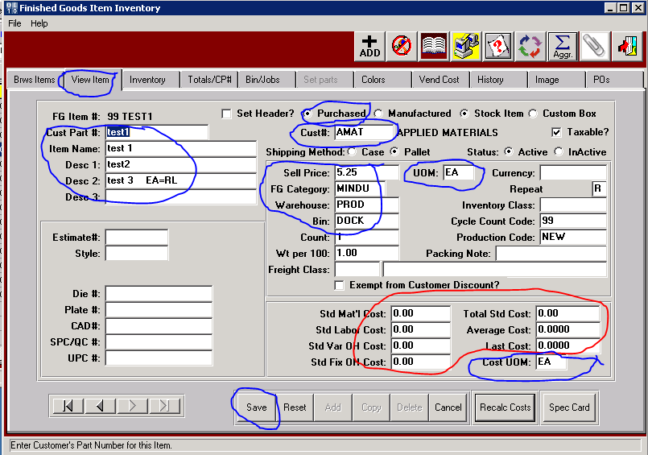

- Click Save at bottom and next screen will appear. Be sure all boxes are checked and click OK
Since this is a new item no orders will be updated.
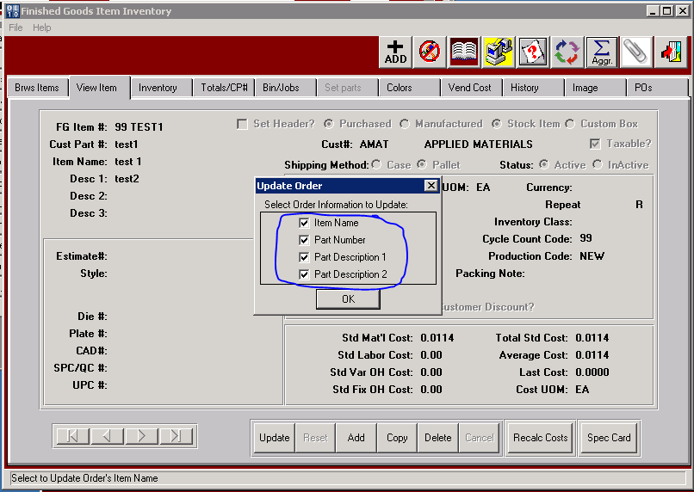
At this point make sure System did not jump to a different item.
When this happens and you will have to click on the “Brws Items” tab, find the new item you are setting up and then click on the Inventory tab.

Click “Inventory” Tab at the top.
Click “Update” at the bottom
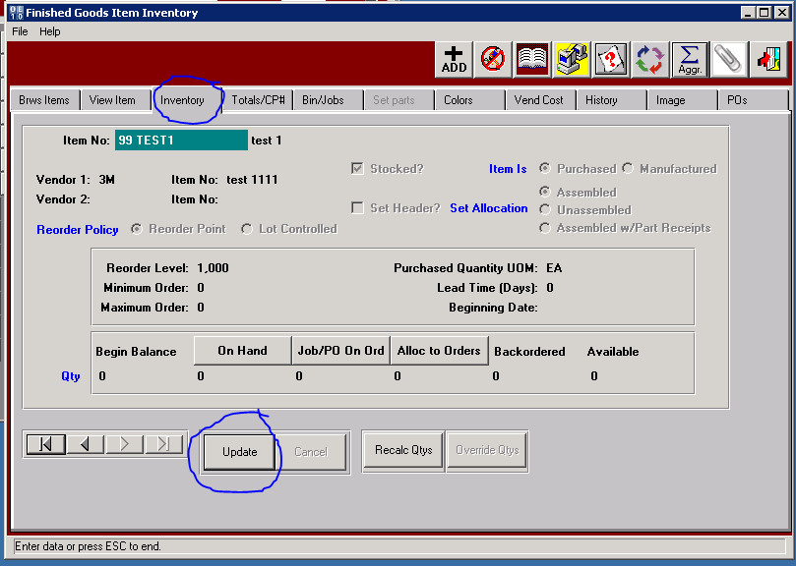
- Vendor 1: Insert vendor ID
- Item No: Insert Vendor item number
- Check stocked if warehousing item with reorder level.
- Click Purchased radial button.
- Click Reorder Point radial button if keeping stock in warehouse.
- Reorder Level: Quantity should be level at which you want to reorder allowing for lead time.
- Purchase Quantity UOM: Change to EA
- Click Save
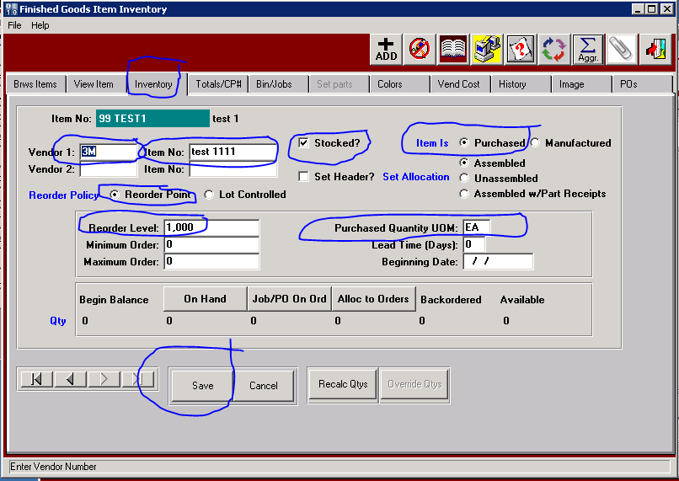
Click “Vendor Cost” Tab.
All existing Vendors and Costs will be copied from the original FG Item we copied.
Click “Copy”
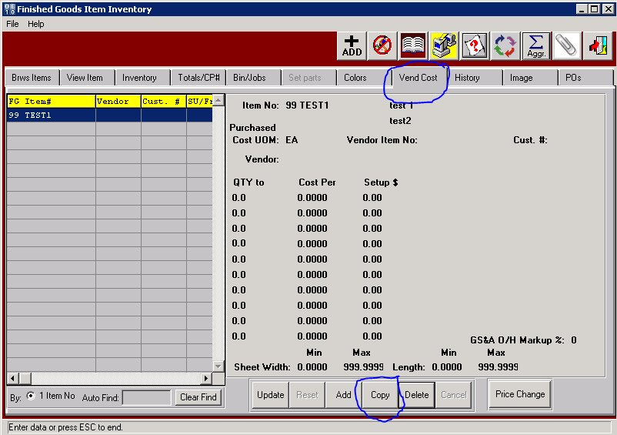
Purchased Cost UOM: This must match UOM on View Item Tab, either “EA” or “M”
Please note, The Vendor Cost UOM may be different from the Sell Price or Consumption UOM.
The program will convert the Purchased Cost UOM into the Stock/Cons UOM during Receiving.
Vendor: Enter Vendor ID
QTY to - Enter 9,999,999.9 (Or type cost matrix based on multiple quantity price breaks)
Cost Per - Enter vendors cost per UOM
The cost matrix may be used for price quantity discounts
Vendor Item No: Optional
Cust # Optional (This is to create a special cost by Customer from this Vendor)
Click Save
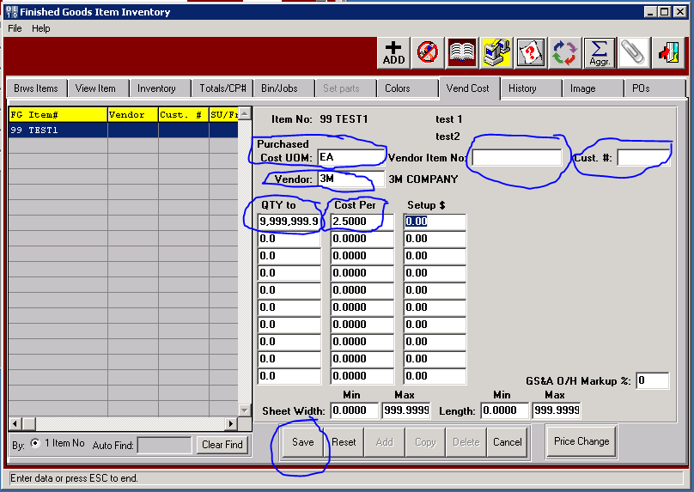

Check screen to make sure all info correct.
